**THE PATTERNS COMPANY**

4th Floor, Bizness Square Junction Opposite Hitex Road, HITEC City, Madhapur, Hyderabad, Telangana 500084

+91-8500693113

+91-9392744210

[info@thepatternscompany.com](mailto:info@thepatternscompany.com)

https://[www.thepatternscompany.com](http://www.thepatternscompany.com/)



Website Report for dermaura.in

This report grades your website based on the strength of various SEO factors such as On Page Optimization, O Page Links, Social and more. The overall Grade is on a A+ to F- scale, with most major, industry leading websites in the A range. Improving your grade will generally make your website perform better for users and rank better in search engines. There are recommendations for improving your website at the bottom of the report. Feel free to reach out to us if you’d like us to help with improving your website’s SEO!

Audit Results for dermaura.in



**D-**

**Your page needs improvement**

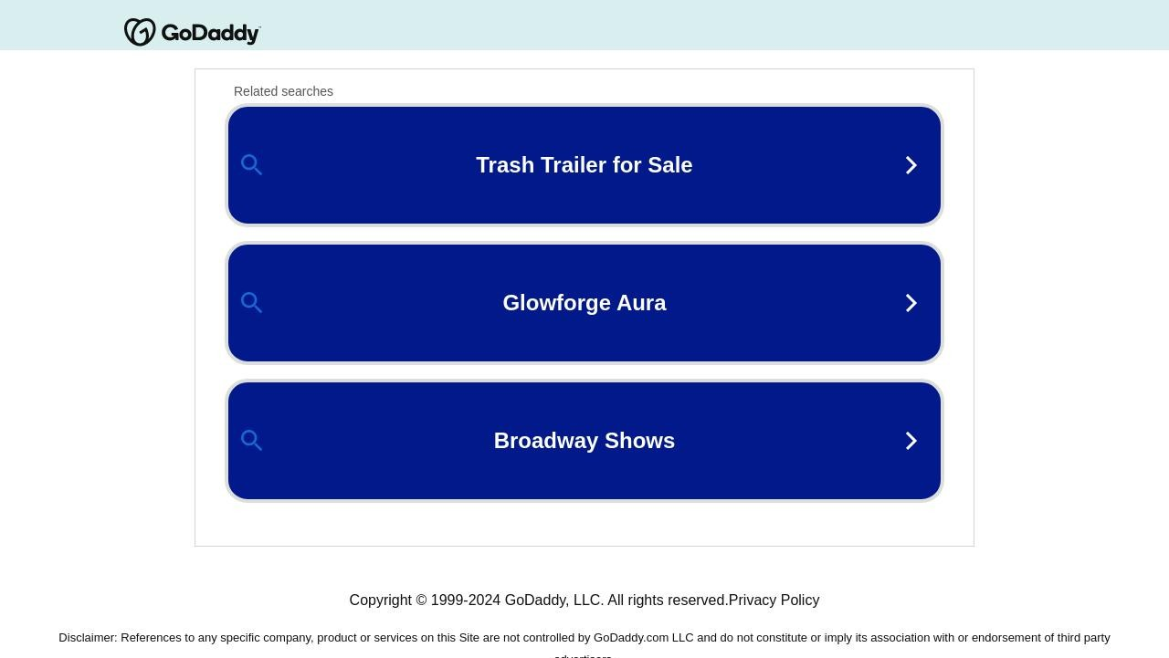

Recommendations: 24

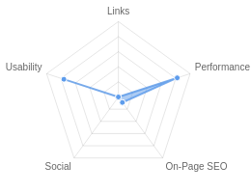



**F**



**F**



**A-**



**A**



**F**

On-Page SEO

Links

Usability

Performance

Social

Recommendations

# Execute a Link Building Strategy

Links

High Priority

**Add a title tag (ideally between 10 and 70 characters)**

On-Page SEO

High Priority

# Include a meta description tag

On-Page SEO

High Priority

**Implement a XML sitemaps file**

On-Page SEO

Medium Priority

# Unblock page in robots.txt

On-Page SEO

Medium Priority

**Add Canonical Tag**

On-Page SEO

Medium Priority

# Add H1 Header Tag

On-Page SEO

Medium Priority

**Make greater use of header tags**

On-Page SEO

Medium Priority

# Use your main keywords across the important HTML tags

On-Page SEO

Low Priority

**Increase page text content**

On-Page SEO

Low Priority

# Make use of HTTP/2+ protocol

Performance

Low Priority

**Create and link your Facebook Page**

Social

Low Priority

# Create and link your Twitter profile

Social

Low Priority

**Optimize your page for Mobile PageSpeed Insights**

Usability

Low Priority

# Implement an analytics tracking tool

On-Page SEO

Low Priority

**Add Schema Markup**

On-Page SEO

Low Priority

# Please add Facebook Open Graph Tags

Social

Low Priority

**Add Twitter Cards**

Social

Low Priority

# Setup & Install a Facebook Pixel

Social

Low Priority

**Create and link associated Instagram profile**

Social

Low Priority

# Create and link an associated YouTube channel

Social

Low Priority

**Create and link an associated LinkedIn profile**

Social

Low Priority

# Add Local Business Schema

Other

Low Priority

**Create Google Business Profile**

Other

Low Priority

On-Page SEO Results

# Your On-Page SEO needs improvement



**F**

Your page is not well optimized from an On-Page SEO perspective. On-Page SEO is important to ensure Search Engines can understand your content appropriately and help it rank for relevant keywords. You should ensure that HTML Tag Content is completed correctly and align text content to target keywords.

# Title Tag

Your page does not appear to have a title tag.

Title tags are very important for search engines to correctly understand and categorize your content.

# Meta Description Tag

Your page appears to be missing a meta description tag.

A meta description is important for search engines to understand the content of your page, and is often shown as the description text blurb in search results.

# SERP Snippet Preview

This illustrates how your page may appear in Search Results. Note, this is intended as a guide and Search Engines are more frequently generating this content dynamically.

https://dermaura.in ⋮

# Hreflang Usage

Your page is not making use of Hre ang attributes.

# Language

Your page is using the lang attribute. Declared: English

# H1 Header Tag Usage

Your page does not have an H1 Header Tag.

The H1 Header Tag is an important way of signaling to search engines what your content is about, and subsequently the keywords it should rank for.

# H2-H6 Header Tag Usage

Your page is not making use of multiple levels of Header Tags.

HTML header tags are an important way of signaling to search engines the important content topics of your page, and subsequently the keywords it should rank for.

|  |  |
| --- | --- |
| Header Tag | Frequency |
| H2 | 0 |
| H3 | 0 |
| H4 | 0 |
| H5 | 0 |
| H6 | 0 |

# Keyword Consistency

Your page's main keywords are not distributed well across the important HTML tags.

Your page content should be focused around particular keywords you would like to rank for. Ideally these keywords should also be distributed across tags such as the title, meta and header tags.

Individual Keywords

Keyword Title Meta Description

Tag

Headings Tags Page Frequency

godaddy    2

llc    2

copyright    1

services    1

party    1

endorsement    1

association    1

imply    1

# Amount of Content

Your page has a low volume of text content which search engines can interpret as 'thin content'. Word Count: 45

It has been well researched that higher text content volumes are related to better ranking ability in

general.

# Image Alt Attributes

You do not have any images missing Alt attributes on your page.

# Canonical Tag

Your page is not using the Canonical Tag.

The Canonical Tag tells Search Engines the primary URL of a page. Google recommends all pages specify a Canonical.

# Noindex Tag Test

Your page is not using the Noindex Tag which prevents indexing.

# Noindex Header Test

Your page is not using the Noindex Header which prevents indexing.

# SSL Enabled

Your website has SSL enabled.

# HTTPS Redirect

Your page successfully redirects to a HTTPS (SSL secure) version.

# Robots.txt

Your website appears to have a robots.txt le.

<http://dermaura.in/robots.txt>

# Blocked by Robots.txt

Your page appears to be blocked by robots.txt, meaning that Google is being instructed to avoid crawling or displaying it in Search Results.

Robots.txt is a set of instructions for web crawlers for how to crawl a website. Blocking les or folders can sometimes be accidental, with signi cant implications.

# XML Sitemaps

We have not detected or been able to retrieve a XML sitemaps le successfully.

Sitemaps are recommended to ensure that search engines can intelligently crawl all of your pages.

# Analytics

We could not detect an analytics tool installed on your page.

Website analytics tools like Google Analytics assist you in measuring, analyzing and ultimately improving tra c to your page.

# Schema.org Structured Data

We have not detected any usage of Schema.org on your page.

Schema.org is a structured data markup for webpages which helps Search Engines understand your site better and provide rich snippets directly in their search results.

Rankings

# Keyword Positions

This shows you a summary of the positions for your Keyword Rankings. The higher you rank, the more likely you are to capture tra c, with recent research showing that as much as 92% of clicks happen on the rst page.

|  |  |
| --- | --- |
| Position | Keywords |
| Position 1 | 0 |
| Position 2-3 | 0 |
| Position 4-10 | 0 |
| Position 11-20 | 0 |
| Position 21-30 | 0 |
| Position 31-100 | 0 |

Links

# Backlink Summary

You have a reasonably weak level of backlink activity to this page.

Search Engines use backlinks as a strong indicator of a page's authority, relevance and ranking potential. There are various strategies available to gain links to a page to improve this factor



**0**



**0**

Domain Strength

Page Strength



**0**

Backlinks

**0**

Referring Domains

|  |  |  |  |  |  |
| --- | --- | --- | --- | --- | --- |
| **0**  Nofollow Backlinks | **0**  Dofollow Backlinks | **0**  Edu Backlinks | **0**  Gov Backlinks | **0**  Subnets | **0**  IPs |

# Top Backlinks

We haven't found any backlinks to report for this site.

# Top Pages by Backlinks

We haven't found any Top Pages data for this site.

# Top Anchors by Backlinks

We haven't found any Anchor Text data for this site.

# Top Referring Domain Geographies

We haven't found any Geographic Data for this site.

# On-Page Link Structure

We found 0 total links. 0% of your links are external links and are sending authority to other sites. 0% of your links are nofollow links, meaning authority is not being passed to those destination pages.

# Friendly Links

Your link URLs appear friendly (easily human or search engine readable).

Usability

# Your usability is good



**A-**

Your page is mostly usable across devices. Usability is important to maximize your available audience and minimize user bounce rates (which can indirectly a ect your search engine rankings).

# Device Rendering

This check visually demonstrates how your page renders on di erent devices. It is important that your page is optimized for mobile and tablet experiences as today the majority of web tra c comes from these sources.

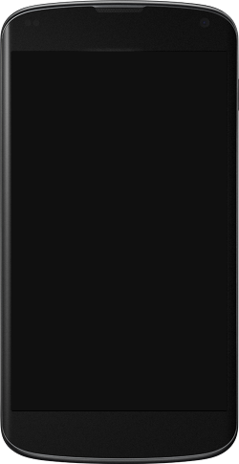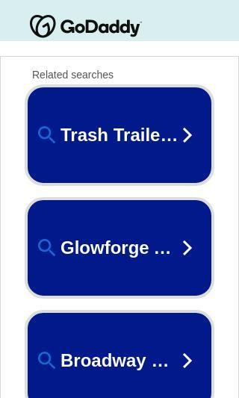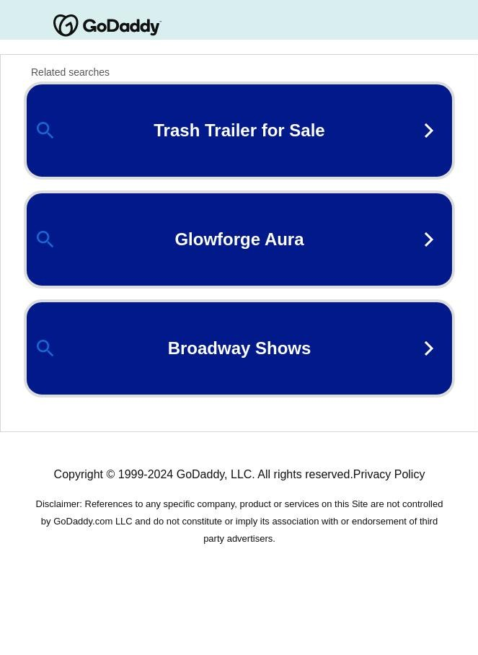

# Google's Core Web Vitals

Google is indicating that they do not have 'su cient real-world speed data for this page' in order to make a Core Web Vitals assessment. This can occur for smaller websites or those that are not crawl- able by Google.

# Use of Mobile Viewports

Your page speci es a viewport matching the device's size, allowing it to render appropriately across devices.

# Google's PageSpeed Insights - Mobile

Google is indicating that your page is scoring poorly on their Mobile PageSpeed Insights evaluation.

Note that this evaluation is being performed from US servers and the results may di er slightly from an evaluation carried out from Google's PageSpeed Web Interface as that reporting localizes to the region in which you are running the report.

Google has indicated that the performance of a webpage is becoming more important from a user and subsequently ranking perspective.



**64**

Opportunities Estimated Savings

Eliminate render-blocking

resources

1.05 s

|  |  |
| --- | --- |
| Lab Data | Value |
| First Contentful Paint | 2.3 s |
| Speed Index | 3.5 s |
| Largest Contentful Paint | 4.4 s |
| Time to Interactive | 4.4 s |
| Total Blocking Time | 0.36 s |
| Cumulative Layout Shift | 0.235 |

Reduce unused JavaScript 1.02 s

Avoid multiple page redirects 0.63 s

# Google's PageSpeed Insights - Desktop

Google is indicating that your page is scoring well on their Desktop PageSpeed Insights evaluation.



**97**

Lab Data Value

First Contentful Paint 0.8 s

Opportunities Estimated Savings

Speed Index 1.1 s

Largest Contentful Paint 1 s

Time to Interactive 1 s

Avoid multiple page redirects 0.19 s

Eliminate render-blocking

resources

0.29 s

Total Blocking Time 0.03 s

Cumulative Layout Shift 0.062

# Flash Used?

No Flash content has been identi ed on your page.

# iFrames Used?

There are no iFrames detected on your page.

# Favicon

Your page has speci ed a favicon.

# Email Privacy

No email addresses have been found in plain text on your page.

# Legible Font Sizes

The text on your page appears to be legible across devices.

# Tap Target Sizing

The links and buttons on your page appear to be appropriately sized for a user to easily tap on a touchscreen.

Performance Results

# Your performance is good

Your page has performed well in our testing meaning it should be reasonably responsive for your users, but there is still room for improvement. Performance is important to ensure a good user experience, and reduced bounce rates (which can also indirectly a ect your search engine rankings).



**A**

# Page Speed Info

Your page loads in a reasonable amount of time.

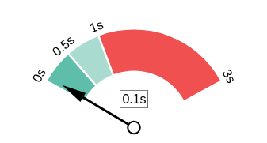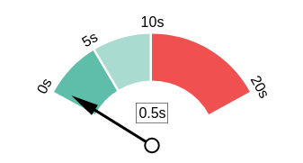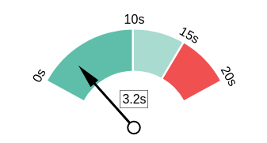Server Response All Page Content Loaded All Page Scripts Complete

# Download Page Size

Your page's le size is reasonably low which is good for Page Load Speed and user experience.

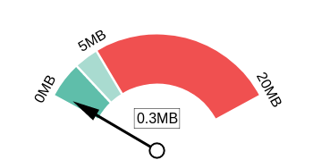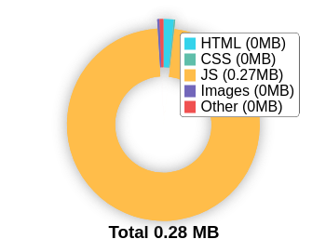Download Page Size Download Page Size Breakdown

# Website Compression (Gzip, Deflate, Brotli)

Your website appears to be using a reasonable level of compression.

Compression Rates Raw Page Size Breakdown

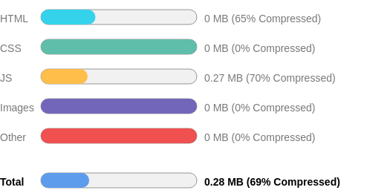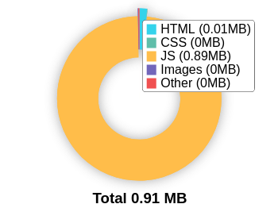

# Number of Resources

This check displays the total number of les that need to be retrieved from web servers to load your page.



18

Total Objects

4

Number of HTML Pages

6

Number of JS Resources

1

Number of CSS Resources

2

Number of Images

5

Other Resources

# Google Accelerated Mobile Pages (AMP)

This page does not appear to have AMP Enabled.

# JavaScript Errors

Your page is not reporting any JavaScript errors.

# HTTP2 Usage

Your website is using an outdated HTTP protocol.

We recommend enabling HTTP/2+ or protocol for your website as it can signi cantly improve page load speed for users.

# Optimize Images

All of the images on your page appear to be optimized.

# Minification

All your JavaScript and CSS les appear to be mini ed.

# Deprecated HTML

No deprecated HTML tags have been found within your page.

# Inline Styles

No inline styles have been found within your page's HTML tags.

Social Results

# Your social needs improvement



**F**

You appear to have a weak social presence or level of social activity (or we may just not be able to see your pro les!). Social activity is important for customer communication, brand awareness and as a marketing channel to bring visitors to your website. We recommend that you list all of your pro les on your page for visibility, and begin to build a following on those networks.

# Facebook Connected

No associated Facebook Page found as a link on your page.

# Facebook Open Graph Tags

We have not found Facebook Open Graph Tags on your page.

Facebook Open Graph Tags are a type of structured data that can be placed on your page to control what content is shown when a page is shared on Facebook.

# Facebook Pixel

We have not detected a Facebook Pixel on your page.

Facebook's Pixel is a useful piece of analytics code that allows you to retarget visitors if you decide to run Facebook Ads in future.

# Twitter Connected

No associated Twitter pro le found as a link on your page.

# Twitter Activity

No associated Twitter pro le found as a link on your page.

# Twitter Cards

We have not detected Twitter Cards on your page.

Twitter Cards are a type of structured data that can be placed on your page to control what content is shown when a page is shared on Twitter.

# Instagram Connected

No associated Instagram pro le found linked on your page

# LinkedIn Connected

No associated LinkedIn pro le found linked on your page.

# YouTube Connected

No associated YouTube channel found linked on your page.

# YouTube Activity

No associated YouTube channel found linked on your page.

Local SEO

# Local Business Schema

No Local Business Schema identi ed on the page.

# Google Business Profile Identified

No Google Business Pro le was identi ed that links to this website.

# Google Business Profile Completeness

No Google Business Pro le was identi ed that links to this website.

# Google Reviews

No Google Business Pro le was identi ed that links to this website.

Technology Results

# Technology List

These software or coding libraries have been identi ed on your page.

Technology Version



Nginx

OpenResty

# Server IP Address



76.223.67.189

# DNS Servers

ns43.domaincontrol.com ns44.domaincontrol.com

# Web Server

openresty

# Charset

text/html



[https://www.thepatternscompany.com](https://www.thepatternscompany.com/)

**The Purpose of a Business is to create a Customer Who Creates Customer’s**

**Thank you**